Pobalscoil Neasáin
School Avoidance Pack

Information for Parents/Guardians

Adopted from the Clare School Avoidance Toolkit: A collaboration between CAMHS, HSE Clinical Psychology Department, School Completion Programme, Child and Young People’s Services Committee, EWO, NEPS and Tusla Family Support Services

This Resource Pack is based on current knowledge in this area. It is intended as a guide only. Not all the suggestions here will apply to any one student or situation.

Contents | Page
What is school avoidance? | 2
What causes school avoidance? | 3
How does school avoidance come about? | 4
Information for Parents/Guardians on Possible Precursors to School Avoidance | 5
What can you as a parent/guardian do to help? | 6
Information & Tips | 6
Useful Contact Details | 7
- What is school avoidance?

School avoidance is a systemic difficulty and refers to student, parent/guardian and school challenges where the student finds it difficult to attend or stay in school. The parent/guardian and school may find it difficult to support the young person, which often results in the request for involvement of other services.
School avoidance may happen at any age but most typically occurs in those between 5 and 7 years of age, and those between 11 and 14 years of age. Generally, the student refuses to attend school and experiences significant distress.
School avoidance differs from truancy in that the young person is at home with the knowledge of the family despite their efforts to enforce attendance. The behaviour is differentiated from parents/guardians who deliberately withdraw a young person from school. It is also differentiated from youths experiencing difficult circumstances that prevent adequate school attendance.

- What causes school avoidance?
There are lots of reasons why a young person might refuse school, and pinpointing the cause can be difficult. Often there are a number of factors that contribute to a young person’s non-attendance. It is important to understand and address underlying issues when supporting young persons to return to school or attend consistently.
Predisposing Factors include;
- Student’s temperament
- Environmental factors
- Family context including parental mental and/or physical health and coping skills
- Inconsistent parent discipline style
- Marital disharmony
The following factors can also be involved in school avoidance;
- A parent(s) being ill, separating, having marital problems, or having frequent arguments.
- Traumatic events, such as family illness, grief or domestic abuse.
- A death in the family or a death of a friend of the young person.
- Jealousy of a new infant sibling.
- Excessive parental worrying about the young person in some way (for example, poor health). Difficulties with transition, such as moving to a new school, returning to school after a long absence due to illness or entering/exiting primary school
- School factors such as workload and academic pressures, fear or dislike of subjects, finding subjects difficult.
- Peer problems, such as social isolation, bullying or conflict between/with friends
- Anxiety about social situations or activities that involve a performance or evaluation, such as sports days, speaking in front of the class or tests
- Anxiety around being separated from parents or carers
- Rewards inherent in staying at home, such as spending time with a parent, watching TV or playing video games.
- Bullying: unwanted aggressive behaviour among school-aged children involving a real or perceived power imbalance that is repeated or has the potential to be repeated over time.

- How does school avoidance come about?
The following diagram illustrates the cycles of thoughts and feelings that can lead to a student's initial refusal to attend school.
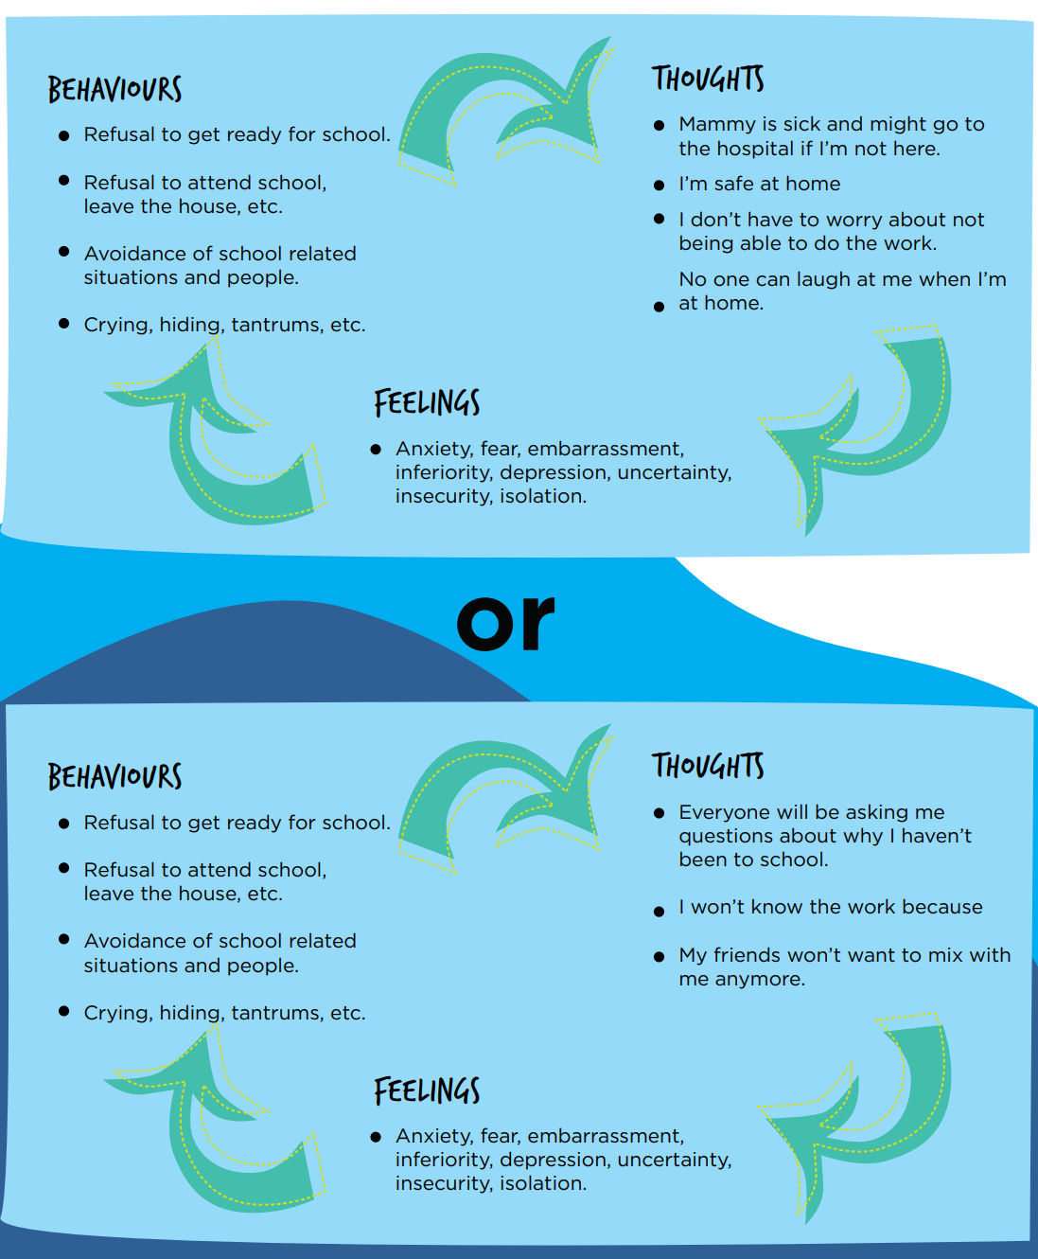
Source: CYPSC Wicklow School Refusal Pack pg. 11

- Information for Parents/Guardians on Possible Precursors to School Avoidance Be on the lookout for:

- Frequent Tearfulness/ distress/ pains in tummy or headaches on Sunday nights or Monday mornings
- Bedwetting or signs of distress/upset on Sunday nights at the thoughts of going back to school on Monday morning.
- Young person showing distress or saying they feel sick when faced with returning to school after a break ( e.g. long weekend or school holidays)
- A pattern of the young person frequently asking the teacher to ring his/her parent from school / wanting to go home/ saying that they are feeling sick
- Prolonged difficulties (anxieties) for a young person when mixing with other persons ( e.g. going outside to play with other children in the neighbourhood; going to after school activities, parties etc.)
- Preoccupation with being organised for school – overly perfectionistic
- A family stressor (e.g. parental separation or bereavement) can trigger some anxious behaviours / feelings about leaving home, or leaving a parent in order to attend school. This is normal. Providing the young person with a calm listening ear, and letting them know that you understand, but that they still need to attend school, can help them to get through a difficult period.

4.1 Adolescents may also show the following behaviour;
- Worry or fear related to school
- Sleeping difficulties and fatigue
- Change of mood, negativity towards school, subjects or teachers
- Increased self-consciousness
- Lack of engagement with school activities, outings, trips
- Poor sense of school belonging

- What can you as a parent/guardian do to help?

- Keep in regular contact with the school by using the school journal, calling and/or arranging a meeting.
- Keep the school up to date with any issues or changes of circumstance that they need to be aware of so that they can help.
- Speak calmly.
- Let them know that you understand.
- Encourage them to talk to you about how they feel.
- Be reassuring.
- Once you have reassured them and helped them to take some slow deep breaths, be persistent and bring your young person to school. This is the right thing to do.
- Give your child some positive self-statements such as : “ I can do this”, “I went to school yesterday and it was fine”.
- Praise them for making the effort to go to school.
- Model positive coping and positive thinking- use examples from your own life.
- Be consistent and present a united front.
- Listen but do not reinforce their fear/anxiety. Make statements such as “I know that you feel ……., we will work on it together, I will help you”.
- Don’t ask leading questions, for example ask, “How are you feeling?” rather than “are you worried?”

  - Information and Tips Resolution can take time and patience for all involved.

- Here are a few suggestions for how to deal with your child if they remain at home:
- If your child is at home during school time make home life less appealing to them - no TV, internet access of tablets and laptops.
- It's recommended that your child get up at the same time every day and put their uniform up.
- They must complete some schoolwork and keep to a routine. Emailing teachers or using Teams is promoted
- Don’t interact too much with your child as this attention can be sometimes rewarding.

Useful Contacts
Name | Address | Contact Details
Education Welfare Officer – offers advice, support and guidance to parents who need support in ensuring that their young person attends school regularly |  | Peter Doherty –( new welfare officer is to be appointed.)
National Educational Psychology Service - NEPS psychologists work with both primary and post-primary schools and are concerned with learning, behaviour, social and emotional development. | NEPS Head Office Dublin Region Department of Education and Skills, Marlborough Street, Dublin 1 | Tel: (01) 889 2700  Email: neps@neps.gov.ie
JIGSAW - Jigsaw Clondalkin is a free, non-judgmental and confidential support service for young people (15- 25). They provide guidance and support for young people who are going through a difficult or distressing time. They also provide advice and guidance for anyone who is concerned about a young person in their life or work. | 44 Essex Street East, Temple Bar, Dublin 2.  Becket House, Summerhill, Dublin 1. | Tel: 016583070  Email: dublincity@jigsaw.ie
Child & Adolescent Mental Health Service (CAMHS) – Youth Mental Health Serives. Assessment and treatments for young people (up to 18) and their families who are experiencing mental health difficulties. Referred to by a GP. | Numerous locations. | Website:  CAMHS, Child and Adolescent Mental Health Services - HSE.ie
Baldoyle Family Resource: Support communities, families and individuals. They offer services like counselling, family support sessions | Grange Road, Baldoyle. Between the Credit Union and the Youth Club. | Tel: 01-8326115  Email:reception@bfrs.ie  Website: www.bfrs.ie
Pieta House: provide free counselling to those with suicidal ideation, those engaging in self-harm, and those bereaved by suicide. Staff are fully qualified and provide a professional one-to-one therapeutic service | Unit 22 Santry Way Dublin 9  24 Greenhills Rd, Tallaght, Dublin | Tel: 01 8831000  Tel: 01 4624792
Turas Springboard Family Centre: Provide counselling services for individuals and families | Our Lady Immaculate School, Darndale, Dublin 17, | Website: www.docchildandfamily.ie/  Tel: 018771716/3  Email: turas@docharity.ie

