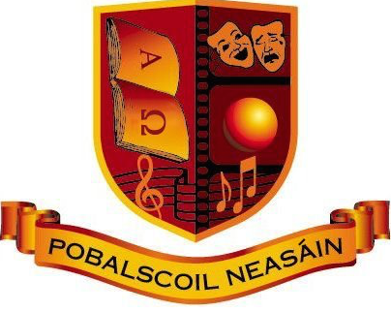
DEPUTY PRINCIPAL

Pobalscoil Neasáin, School Lane, Baldoyle, Dublin 13
Category XVII

The Board of Management of Pobalscoil Neasáin invites applications from suitably qualified persons for the post of Deputy Principal. The school is a co-educational Community School with an enrolment of 806 on 30/9/2024.
The successful applicant will take up duty on 1st September 2025.

To qualify for appointment candidates must have:
- Recognised post-primary teaching qualification.
- A minimum of 5 years’ satisfactory teaching experience.
- Registration (Route 2) in accordance with Section 30 of the Teaching Council Act 2001.

Application forms and full details may be obtained:

- by download from: www.psn.ie
- or requested by email from BOM@psn.ie

Completed application forms should be submitted in hard copy only, by hand to the school office, or by post, addressed to The Chairperson of the Board of Management, Pobalscoil Neasáin, School Lane, Baldoyle, Dublin 13 no later than 12.00 noon on Monday 16th June 2025.

Short listing may apply.

Interviews will take place on Friday 27th June.

Canvassing by or on behalf of the candidate will automatically disqualify. Late applications will not be accepted.

